1. Console and Cloud Shell

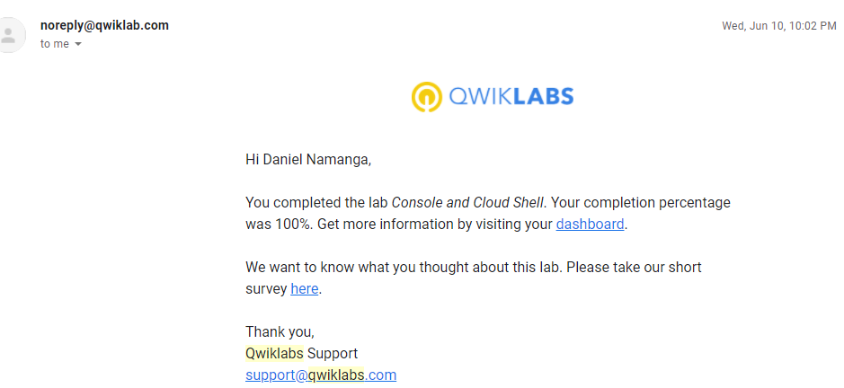

1. Infrastructure Preview

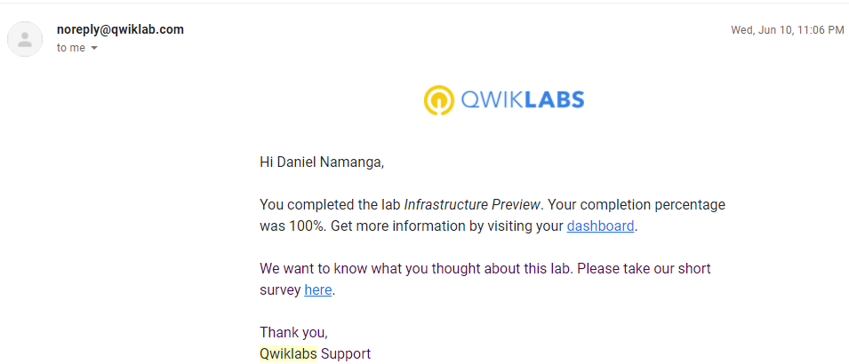

1. VPC Networking

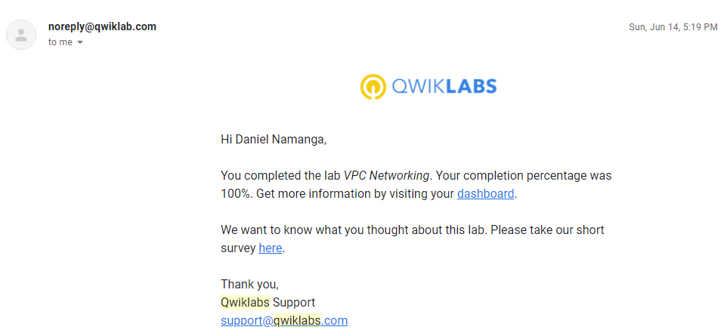

1. Implement Private Google Access and Cloud NAT

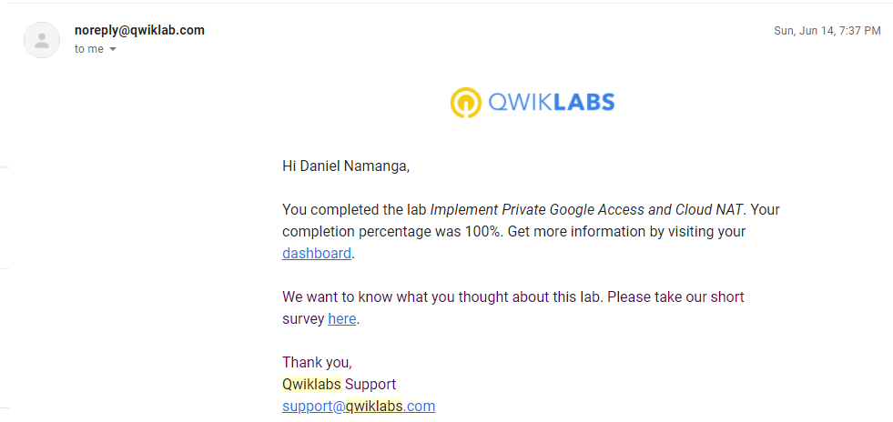

1. Creating Virtual Machines

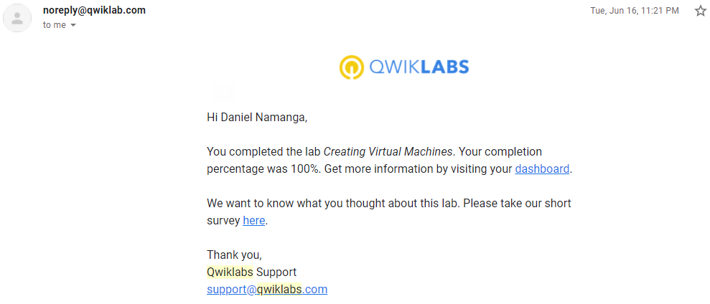

1. Working with Virtual Machines

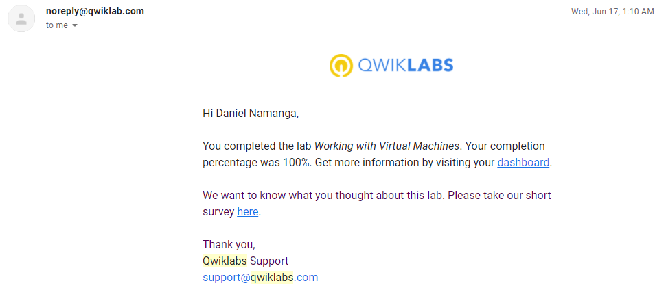

1. Cloud IAM

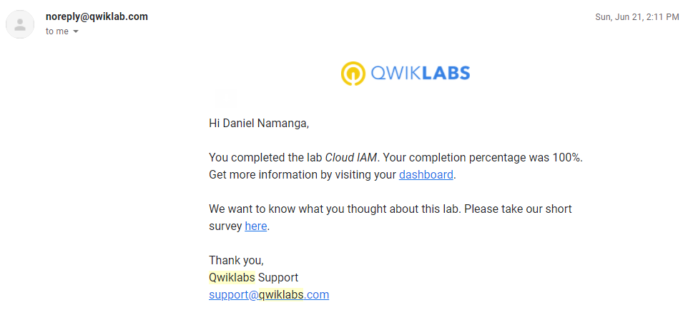

1. Cloud Storage

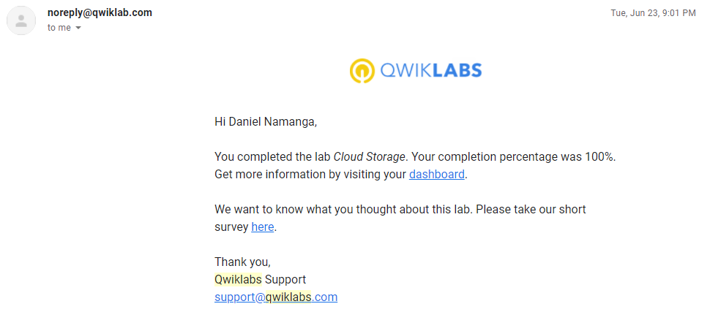

1. Implementing Cloud SQL

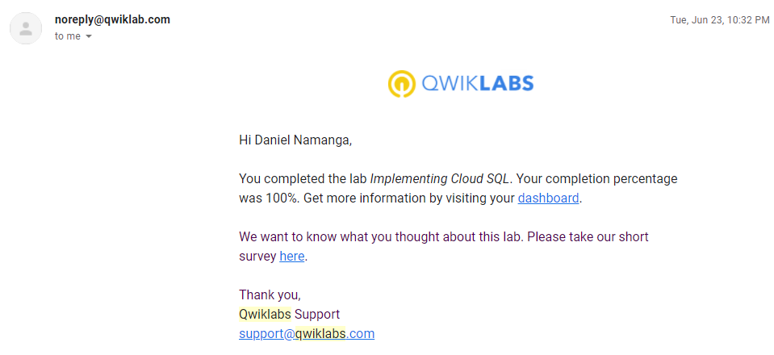

1. Examining Billing data with BigQuery

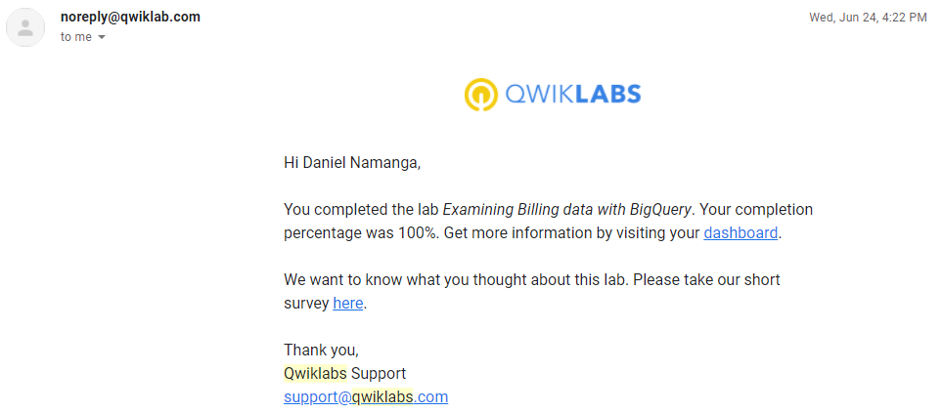

1. Resource Monitoring

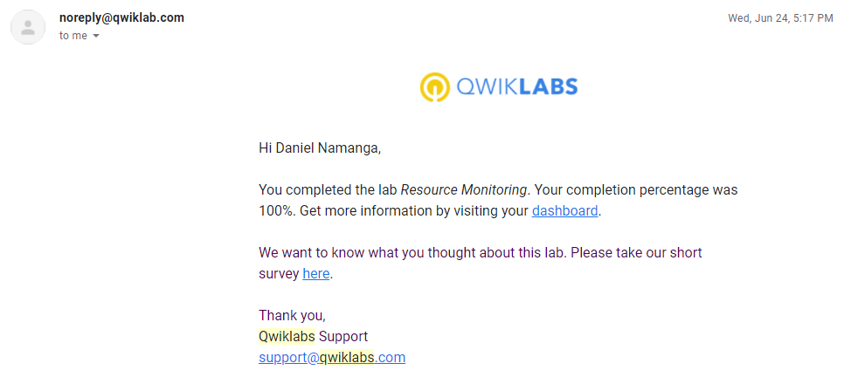

1. Error Reporting and Debugging

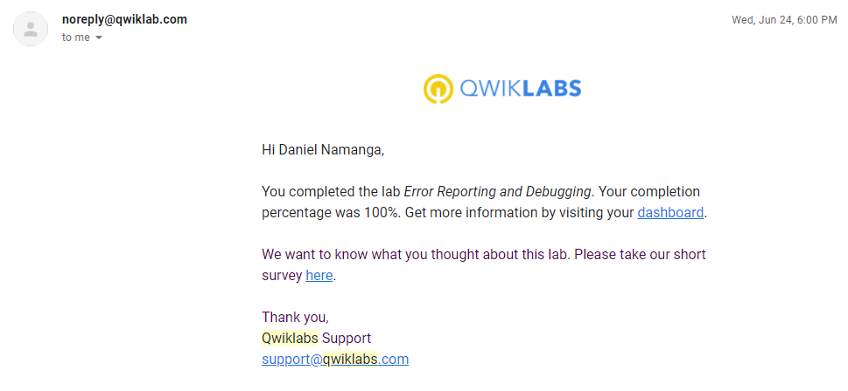

1. Virtual Private Networks

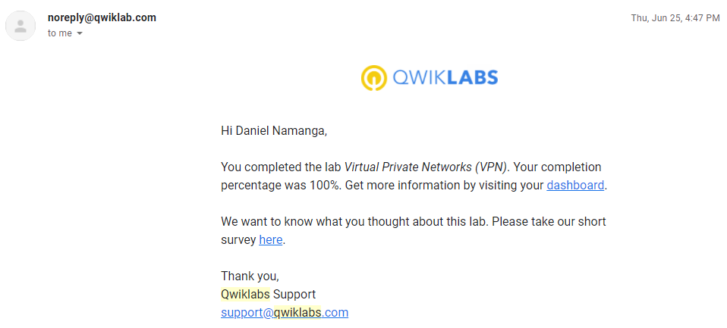

1. Configuring HTTP Load Balancer with Autoscaling

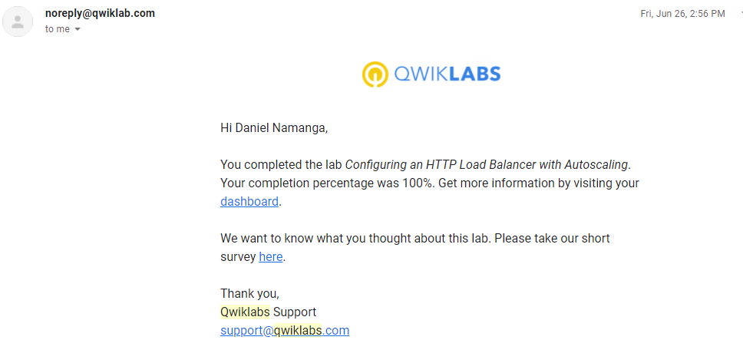

1. Configuring an Internal Load Balancer

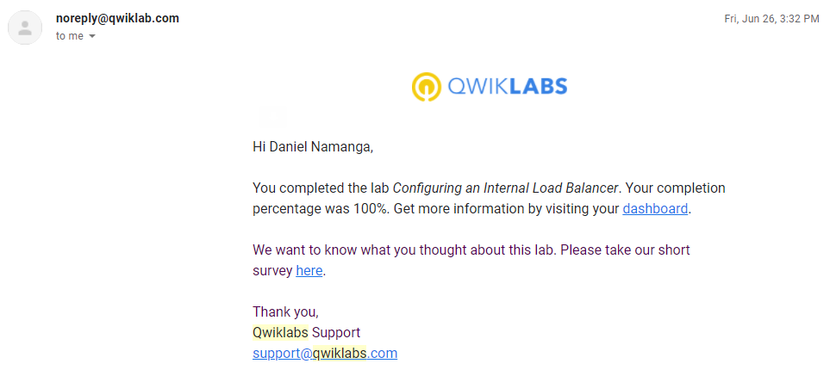

1. Automating the Deployment of Infrastructure Using Deployment Manager

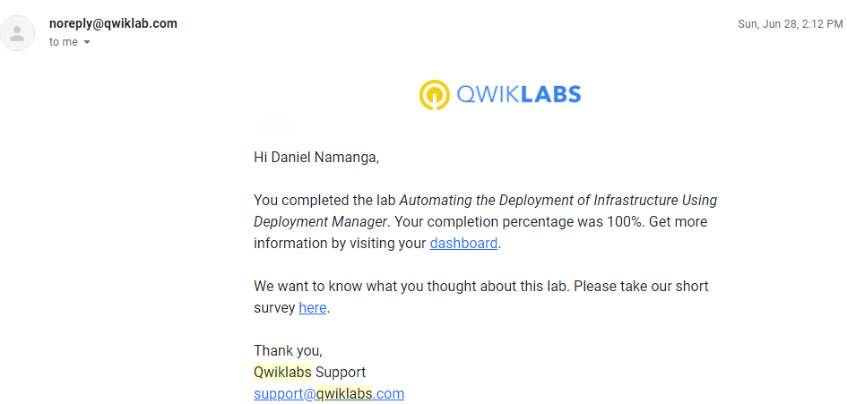

1. Automating the Deployment of Infrastructure using Terraform

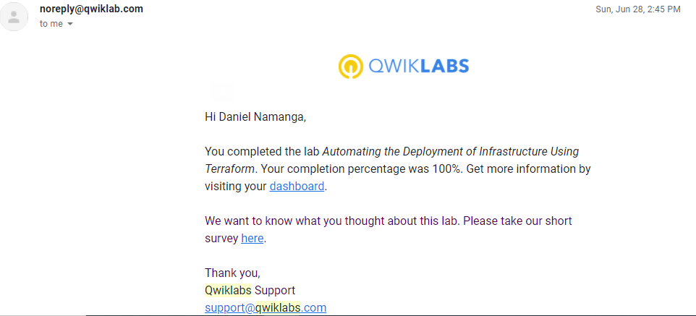

1. Introduction to containers and Docker v1.6

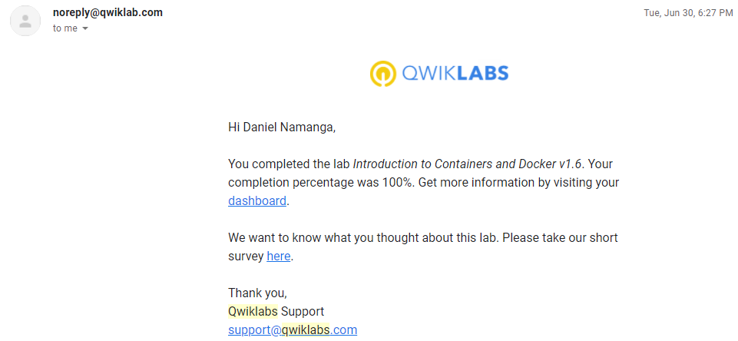

1. Kubernetes Basics v1.6

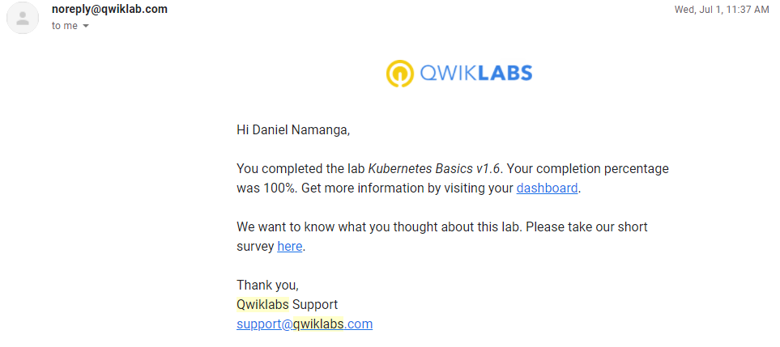

1. Deploying to Kubernetes v1.6

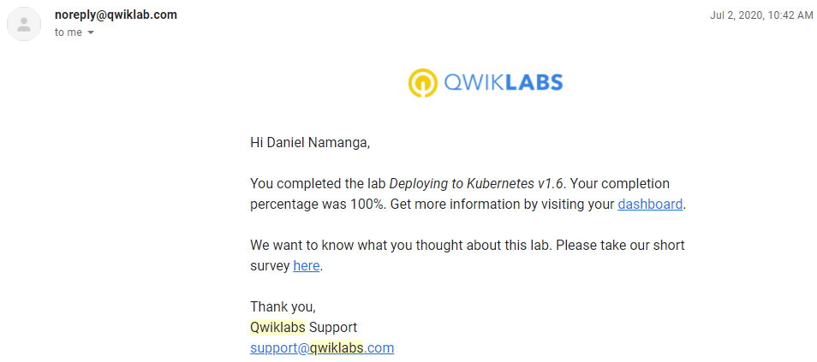

1. Continuous Deployment with Jenkins v1.6

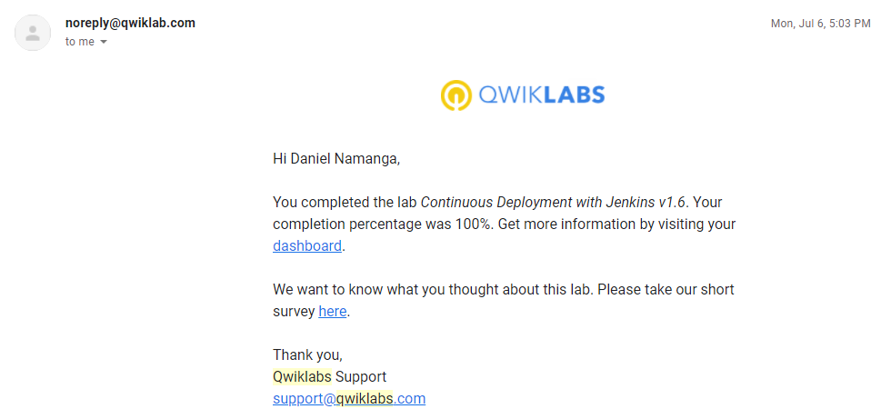

1. Continuous Deployment with Spinnaker v1.6

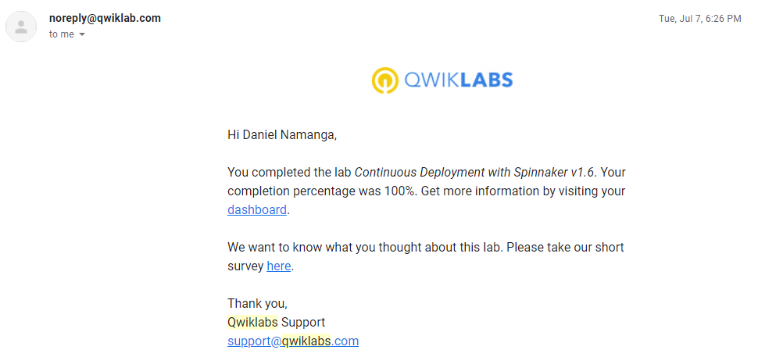

1. Google Cloud Fundamentals: Getting Started with Cloud Marketplace

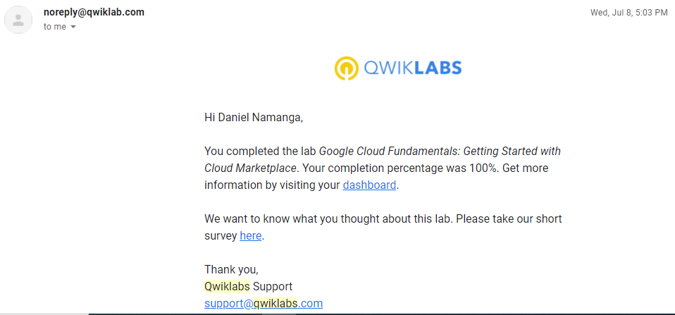

1. Google Cloud Fundamentals: Getting Started with compute Engine

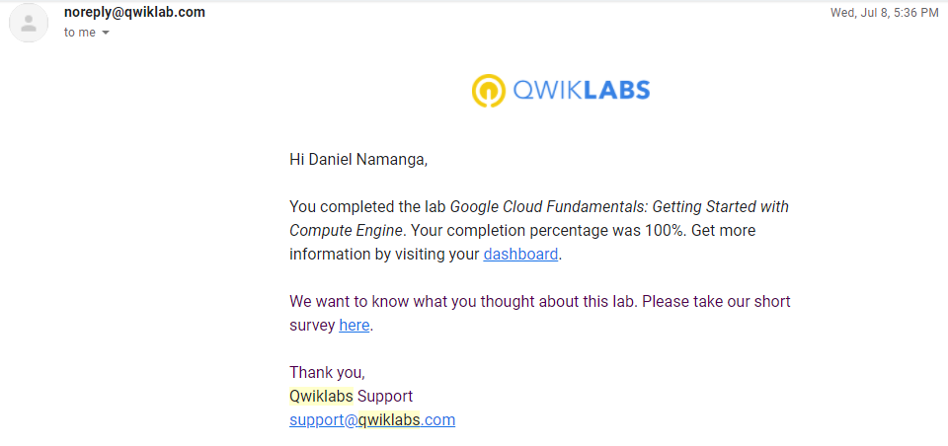

1. Google Cloud Fundamentals: Getting Started with Cloud Storage and Cloud SQL

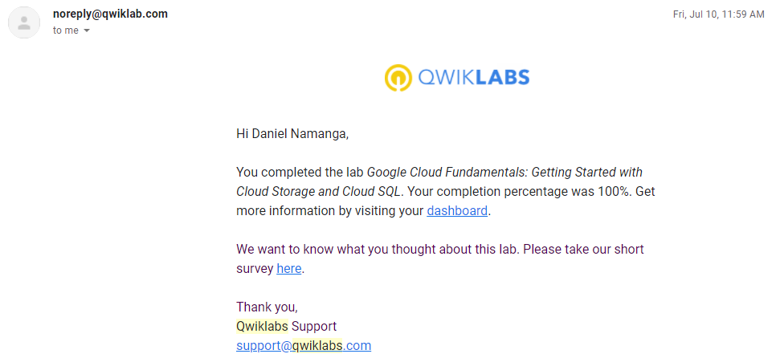

1. Google Cloud Fundamentals: Getting Started with GKE

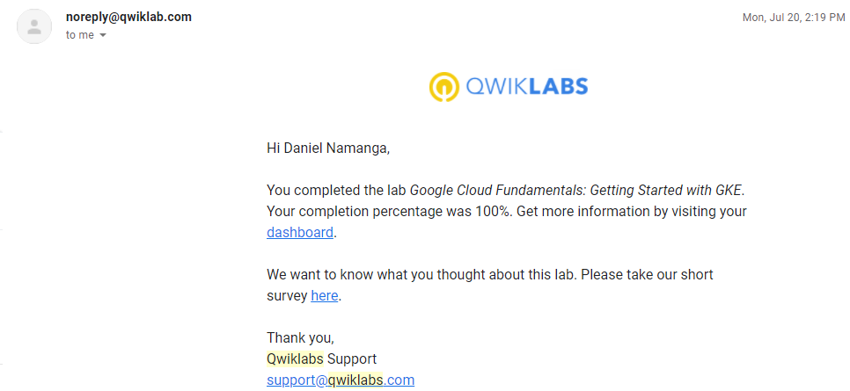

1. Google Cloud Fundamentals: Getting Started with App Engine

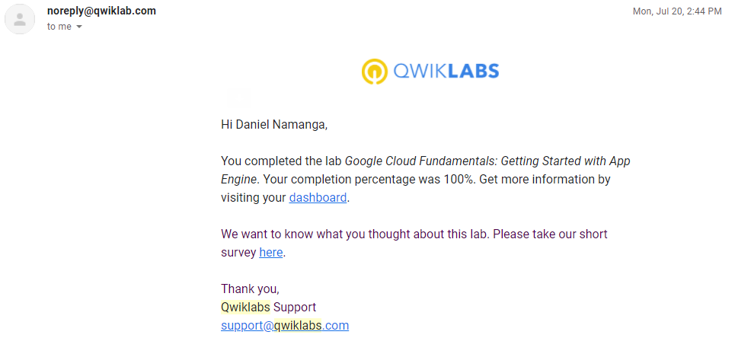

1. Google Cloud Fundamentals: Getting Started with Deployment Manager and Cloud Monitoring

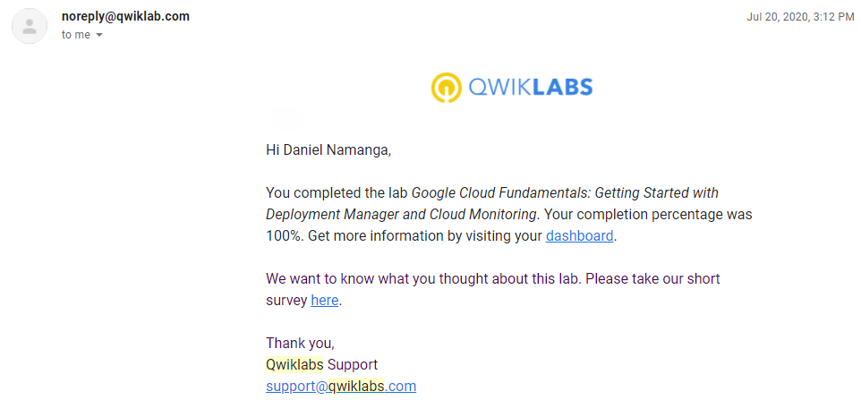

1. Google Cloud Fundamentals: Getting Started with BigQuery

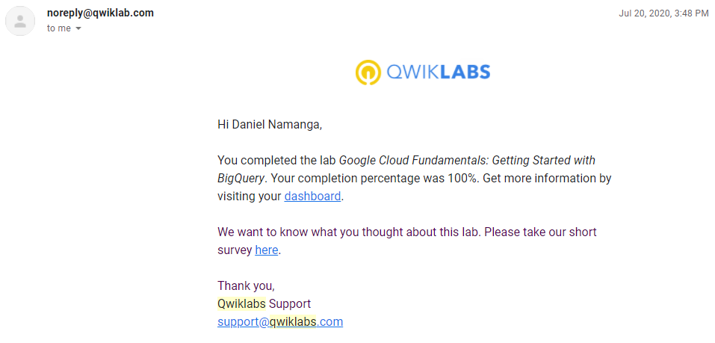

1. App Dev: Setting up a Development Environment v1.1

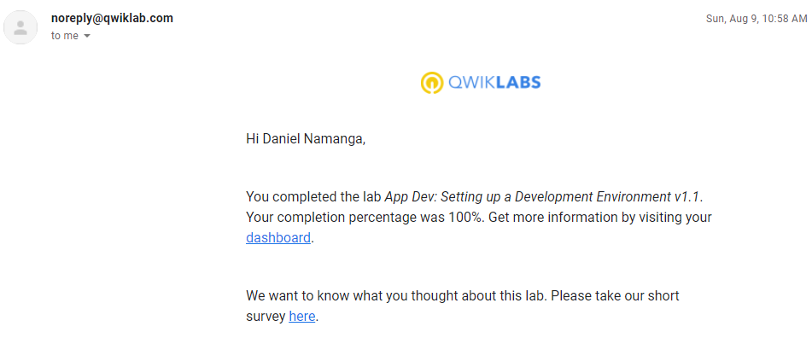

1. App Dev: Storing Application Data in Cloud Datastore v1.1

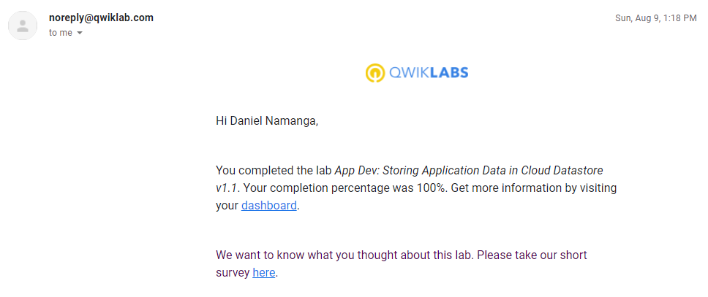

1. App Dev: Storing Image and Video Files in Cloud Storage v1.1

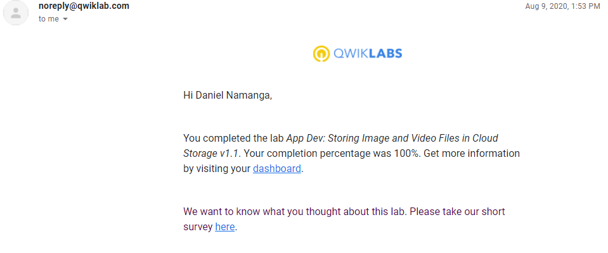

1. Explore a BigQuery Public Dataset

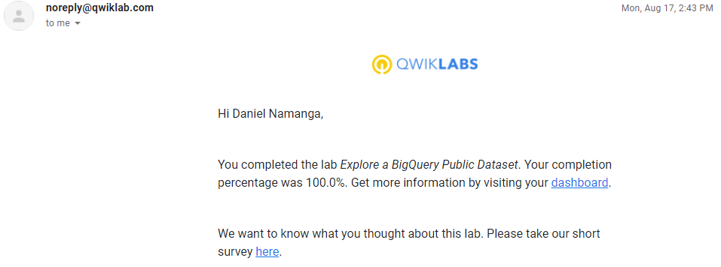

1. Recommend Products using ML with Cloud SQL and Dataproc

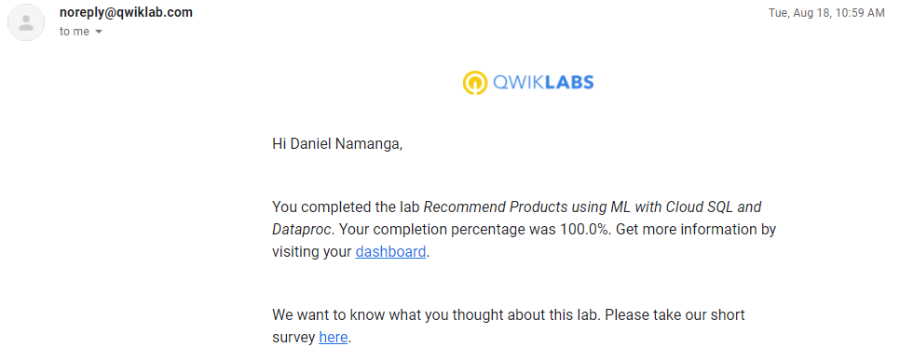

1. Predict Visitor Purchases with a Classification Model with BigQuery ML

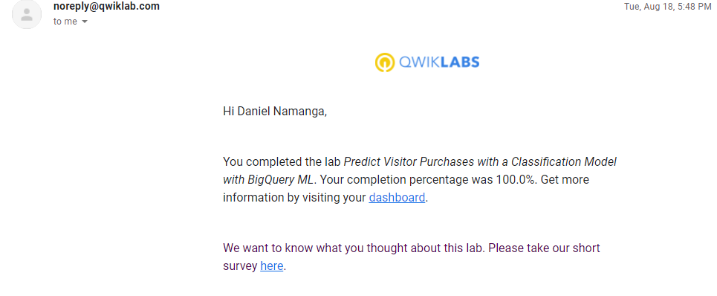

1. Create a Streaming Data Pipeline for a Real-Time Dashboard with Cloud Dataflow

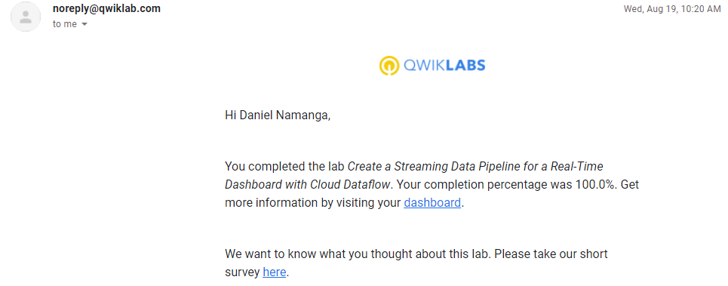

1. Classify Images with Pre-built ML Models using Cloud Vision API and AutoML

